**COMPUTER NETWORKS - CSA07**

**Parthibhan .R**

**192224275**

**EXPRIMENT 16:-**

Simulate a Multimedia Network

Github Link:- <https://github.com/parthibhan007/CSA0748-computer-network/tree/main/expriment%2016>

Simulation:-

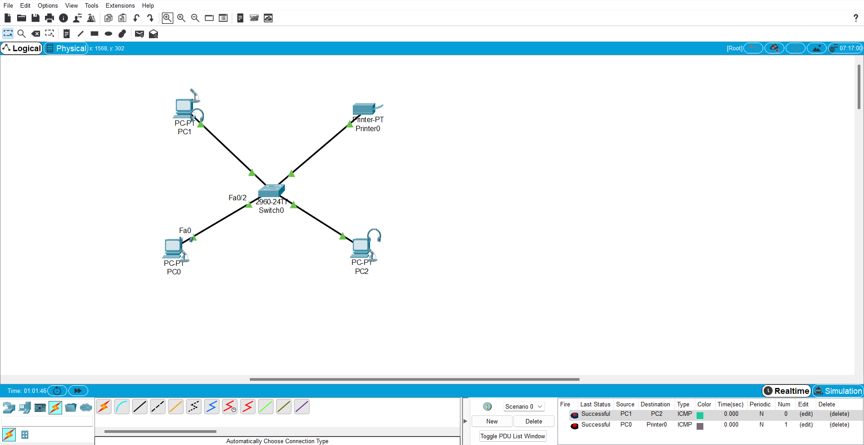

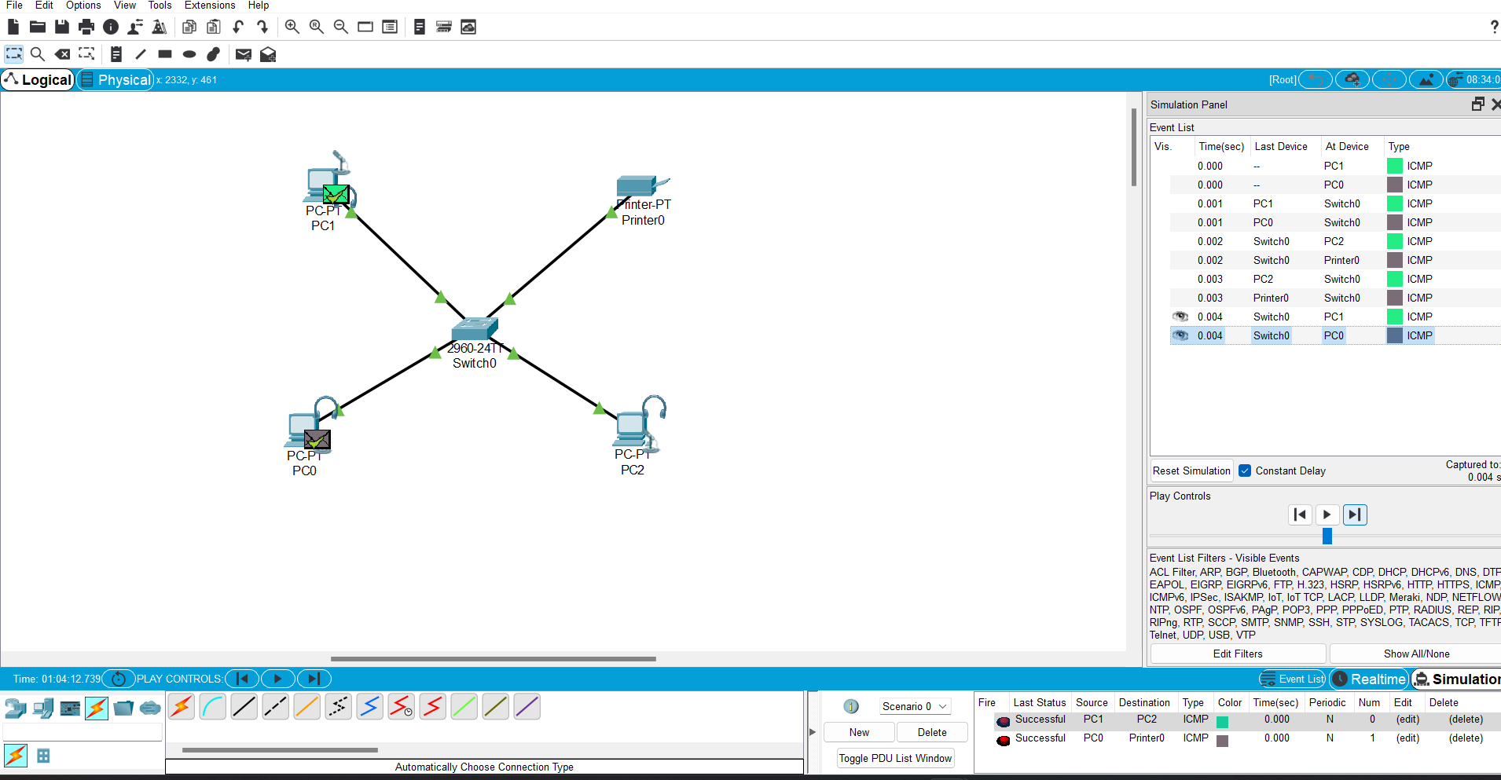

Real Time:-

